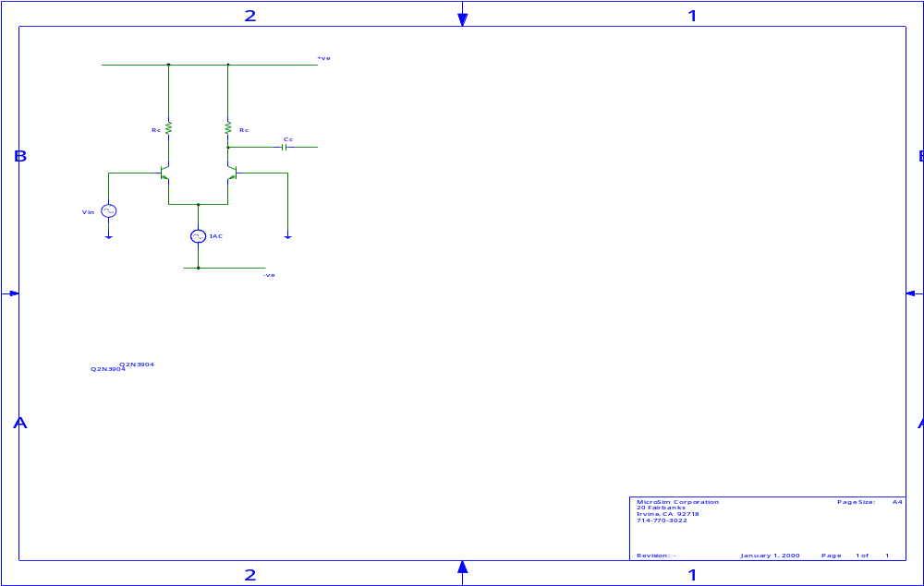
Shown above is the diagram described in the question sheet. To evaluate the “ins and outs” of this circuit, it must be transformed into it’s A.C. equivalent circuit. Hence ground the V_{cc} point, ground the V_{EE} point, open circuit the current source and short circuit the capacitors. Plus for the sake of A.C. analysis the transistor can be changed into its two element model (shown in Fig.2).
Figure 1
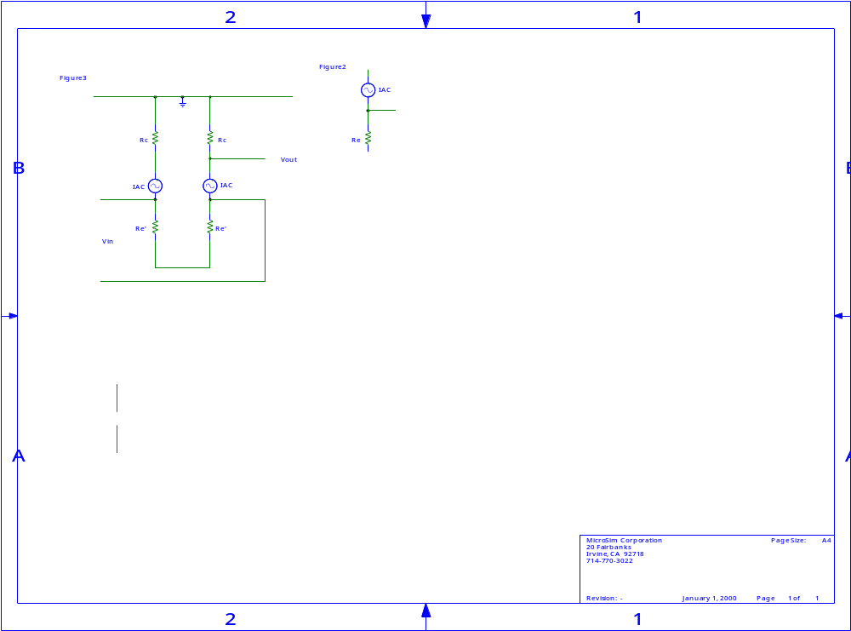
I_{b}
βI_{b}
(1 +βI_{b})

The collector resistor shown on the left transistor circuit is of no consequence to us, it has no part in the input or output characteristics. In figure 3 the two r_{e}’s are seen to be in series, the same ac emitter current exists in both transistors.

i). The ac emitter current is given by:

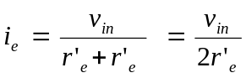

r’_{e} is the intrinsic emitter resistance of the transistor is related to Ie through use of the simple diode equation. In the diagram overleaf it is known (because the β of the two transistors are identical) that each emitter leg has half the share of the dc current Ie. Hence:

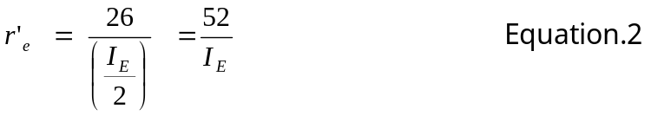

Substituting this Equation.2 back into Equation.1 we have:-

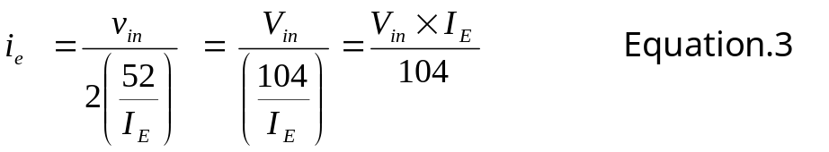

A general aside, the general relationship which links the collector, emitter and base currents is:

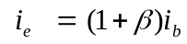

If the equation is now rearranged in terms of I_{b} and knowing that I_{c} is simply

Therefore the ac output voltage is:-

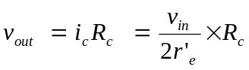
Hence the voltage gain of the circuit is:-

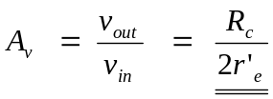

ii). The ac emitter current is given by:-

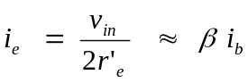

Therefore the input impedance of the circuit is:-

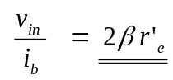
iii). The output resistance is simply the collector resistor (the only form of resistance on the output side of the circuit).
